Final Project Report
Course: Software And Design Architecture Lab
E-Commerce Website
Submitted By

M Sufyan (Group Leader) | FA24-15815
M Yasir Soomro | FA24-15878
Syeda Amal Fatima | FA24-15753

Department of Software Engineering

KARACHI INSTITUTE OF ECONOMICS & TECHNOLOGY
College of Engineering
ABSTRACT

Electronic Commerce is process of doing business through computer networks. A person sitting on his chair in front of a computer can access all the facilities of the Internet to buy or sell the products.

Unlike traditional commerce that is carried out physically with effort of a person to go and sell products, e-commerce has made it easier for human to reduce physical work and to save time. E-commerce which was started in early 1990’s has taken a great leap in the world of computers, but the fact that has hindered the growth of e-commerce is security. Security is the challenge facing e-commerce today & there is still a lot of advancement made in the field of security.

The main advantage of e-commerce over traditional commerce is the seller can browse online plateforms, compare prices and order merchandise sitting at home on their PC or mobile phones.

For a developing country advancement in the field of e-commerce is essential. The research strategy shows the importance of the e-commerce in developing countries for business applications.

TABLE OF CONTENTS
ABSTRACT
1. INTRODUCTION TO PROBLEM 9
1.1 Introduction 9
PROBLEM STATEMENT 10
1.2 Purpose 10
PROJECT SIGNIFICANCE 10
1.3 Objective 11
1.4 Existing solution 11
1.5 Purposed Solution 11
1.6 Scope 12
2 LITERATURE REVIEW 13
3 PROBLEM DEFINITION & REQUIREMENTS ANALYSIS 14
3.1 Problem Definition 14
3.2 Requirement Analysis 15
4 DESIGN & IMPLEMENTATION 16
4.1 Design 17
4.2 Implementation 17
5 TESTING 18
5.1 Testing Procedure & Test Cases: 19
5.2 Results 19
6 FUTURE ENHANCEMENTS 21
6.1 Future Enhancements 21

Appendix A: Bibliography / References

Appendix B: Index

CHAPTER # 1
INTRODUCTION TO PROBLEM

INTRODUCTION TO PROBLEM

Introduction
The Online Shopping system, built using the MVC architecture, makes it easy for Sellers and Admins to manage products and orders. Sellers can add, update, and delete products, as well as track and manage customer orders. They handle the product details and keep everything updated. Admins, on the other hand, have full control over the system. They can manage user accounts, create sales reports, and oversee all orders. In the MVC system, the Model takes care of storing product, and user data, the View gives an easy-to-use interface, and the Controller makes sure everything works smoothly. This setup ensures that both sellers and admins can efficiently manage the store.

Problem Statement
Nowadays, peoples are using online to communication, collaboration, and many things that may be done online. Electronic Commerce (E-Commerce) growth is increasing at a rapid rate and is replacing traditional commerce. The benefits of selling online cannot be underestimated. The E-Commerce offers Internet users a wider range of benefits, reducing Internet users' time for searching the related products. People while sitting at one place can reach to number of products with different varieties and can sell them and would help them at their door step.

Purpose
The purpose of this document is to highlight the requirements of E-Commerce web application. This is a web online store application made in MVC using Database. We want to provide business owners with this application, an easy-to-use online store interface to sell their products and services. This document will describe the functionality of the system in detail and highlight the dependencies that exist if any.

Project Significance
This project’s significance lies in its use of the MVC architecture, ensuring clear separation between data, user interface, and business logic. Built with C#, HTML/CSS, and MSSQL, it provides a scalable, secure, and efficient online shopping platform. The database design, with well-defined relationships between admins, categories, products, and users, ensures smooth management of data. The system is highly maintainable, allowing for future expansion and integration of new features, making it a robust solution for managing an online store.

Objective
The objective of the project is to provide a system which can help the user to shop in easily and pay their credits online without having fear of being theft. The web application provides the user easy interface and online shopping facility. The purpose of the project is to come up with electronic commerce system that is simple and secure for users. The system will provide means by which clients can view products browse for more information about the products, select items and collect them in shopping cart then order or buy products online.

1.4 Existing Solution
In Pakistan, many e-commerce websites are not user-friendly and fail to match the quality of international platforms like Amazon. These sites are often slow, causing users to abandon them and search for faster alternatives.

1.5 Proposed Solution
- Simplified Shopping: Users can easily buy products without visiting multiple sites or stores.
- User-Friendly Experience: Select, check availability, and purchase with a secure payment method.
- Efficient Data Management: Customer data is securely stored and easily managed by admins.
- Attractive and Easy Interface: The site is aesthetically pleasing and simple to navigate.
- Responsive Design: Works seamlessly on mobile phones, tablets, desktops, and laptops.
- Time and Cost Saving: The platform is flexible, fully functional, and saves time and money.
- Guided Process: Users are assisted at every step of registration and purchasing.
- Flexible Selection: Customers can choose products based on their preferences and budget, with real-time availability.

Scope
The application enables quick management of accounts, product listings, and user verification. Admins can easily add, update, or deactivate products, manage categories, and oversee customer orders. Sellers can efficiently manage their own product listings and track their sales. The system ensures that all records are securely stored, preventing manipulation. The platform provides a simple and intuitive interface, making it easy for both admins and sellers to use. Additionally, the system is designed to be scalable, allowing future enhancements and additional features.

CHAPTER # 2
Literature Review

Literature Review
  - E-commerce Platforms and User Experience
User experience (UX) is essential for customer satisfaction in e-commerce. Studies show that platforms with fast load times, smooth navigation, and easy product searches perform better. This project aims to improve user experience by offering a responsive, user-friendly platform for admins and sellers to manage products and orders efficiently, addressing issues seen in many local e-commerce websites.
  - Product Management in E-commerce
Effective product management is key to operational efficiency. Businesses that utilize robust back-end systems for inventory management and order processing see improved performance. This project uses MSSQL for secure product management and streamlined order processing, allowing admins and sellers to easily manage products and customer data.
  - Security and Data Protection in E-commerce
Security is a major concern in e-commerce, especially regarding customer data. Research highlights the importance of secure payment systems and data protection. This project ensures secure data storage and prevents unauthorized access through encryption and user authentication, building customer trust and safeguarding sensitive information.

CHAPTER # 3
Problem definition and requirement analysis

Problem Definition & requirements analysis

Problem Definition
A Vision Document is a software process document that describes the overall 'vision', or plan, for a particular piece of software, the vision provides a high-level, sometimes contractual, basis for the more detailed technical requirements, it captures the "essence" of the predicted solution in the form of high-level requirements and design constraints that give the reader an overview of the system to be developed from a behavioral requirements perspective, it provides input to the project-approval process and is, therefore, closely related to the Business case, it communicates the fundamental "why and what" for the project and is a gauge against which all future decisions should be validated.The system is accessible anytime, anywhere using a smart phone, features cell phone and browser and internet connection to use the services.
A brief statement of work is given as below:
Through this site the user can choose things, check the availability, and buy things by giving required information, User friendly payment process, can check different categories. Help manage the business and keeps records of all the data of the customers. Provide a user interface that is both aesthetically pleasing and easy to use. It saves a lot of time, money and labor. This site is fully functional and flexible

Requirement Analysis
The system’s use case shows the user a detailed view of the system and how the actors would interact with each other and with the system. The explanation for each use case is then provided below the system use case for the administrator and the user , helping the user to understand who are the actors areas as well as giving the description for each use case along with its pre- and post-conditions that should be satisfied once the use case is implemented in the software.

CHAPTER # 4
Design & Implementation

DESIGN & IMPLEMENTATION
This chapter provides the detailed design of the application, outlining how the system will meet the gathered requirements. It includes screen layouts, process diagrams, and other necessary documentation to explain the functionality and operations of the system.
The system is organized into various modules and subsystems, each addressing specific requirements. For each requirement, corresponding design elements are created. These elements include sequence diagrams, database design, class diagrams.
These diagrams serve to clearly define the software features in detail, guiding the development process and minimizing the need for additional design work during implementation. This ensures the system is built according to the specified requirements with a clear roadmap for development.

Data Flow Chart
=>Admin Module
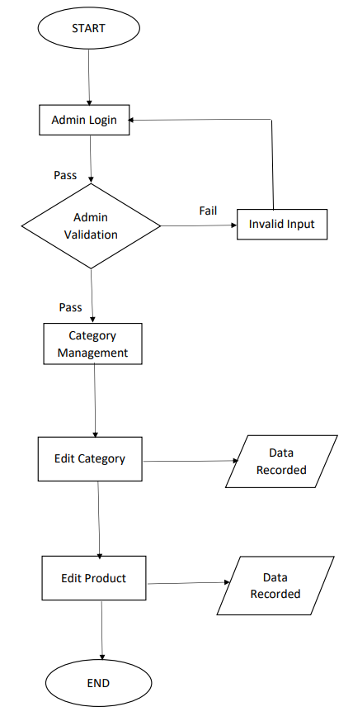

=>User/Seller Module
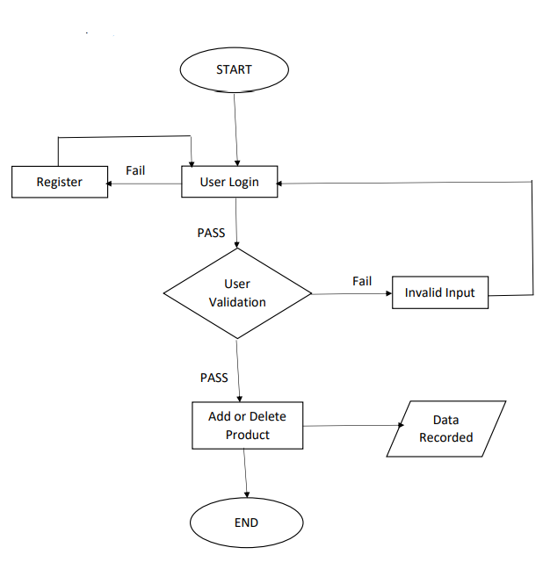

CHAPTER # 5
Tests & Results

TESTING
Software testing is an important process to assess the quality and functionality of the developed e-commerce platform. It provides stakeholders with valuable insights about the software’s performance and helps identify potential issues or defects. Testing ensures that the software meets the specified requirements, functions as expected, and satisfies the needs of the users and stakeholders.
Testing can be described as validating and verifying that the software:
- Meets the requirements that guided its design and development.
- Works as intended and performs the expected functions.
- Can be implemented with consistent characteristics across different environments.
- Satisfies the needs of all stakeholders, including admins, and sellers.
- Verifying that users can register and log in successfully.
- Checking if admins can manage products (add, edit, delete).
- Ensuring that the product search function displays accurate results.

Testing Procedure & Test Cases:
The testing procedure includes defining specific test cases to verify each feature and function of the e-commerce platform. A test case specification outlines the purpose of the test, the required inputs, expected results, and detailed step-by-step procedures for execution. For each test case, we will also establish pass/fail criteria to determine if the feature has been correctly implemented. Some of the test cases for our project will focus on verifying that users can register and log in successfully, admins can manage products (add, edit, delete), the payment process works securely and correctly, and the product search function displays accurate results. Additionally, we will test the responsiveness of the platform across different devices such as mobile phones, tablets, and desktops.

Results
For testing our e-commerce platform, we will primarily use Black Box Testing, a method that focuses on testing the functionality of the software without examining its internal code structure. The aim of this method is to verify whether the system performs as outlined in the requirements and meets user expectations. During Black Box Testing, we will ensure that the platform’s functionalities, such as product purchasing, payment processing, and product searches, operate correctly and efficiently. We will also confirm that the site is responsive across various devices and browsers. This testing approach will help ensure that the software provides the desired user experience and meets the functional requirements of the project.

CHAPTER # 6
Future Enhancements

Future Enhancements
Following are the tools and techniques used for the preparation of project:
- Buyer Module
A dedicated buyer module could be developed to help customers track their orders, view purchase history, manage their profiles, and interact with customer support more easily. This would enhance the overall shopping experience by offering a personalized and user-centric interface.

- Payment Module
A more advanced payment module could be integrated, supporting multiple payment methods like credit/debit cards, e-wallets, and even cryptocurrency. This would provide customers with more payment options, improving convenience and flexibility.

- Account Management Enhancements
Modifying and improving the account management system could offer users the ability to set preferences, save favorite products, and receive personalized notifications. Additionally, more robust password recovery, two-factor authentication (2FA), and other security features could be added for enhanced account protection.

- Improved Search Functionality
Adding advanced search filters and an AI-driven search engine would help users find products faster and more accurately. Features like voice search or image-based product search could also be implemented to make the platform more interactive.

- Order Tracking and Delivery Integration
Enhancing the order tracking system by integrating with third-party delivery services would provide real-time updates and delivery options, improving customer satisfaction and transparency.

- Customer Feedback and Review System
A more interactive customer review system could be added, where buyers can leave ratings, reviews, and feedback on products. This would increase user engagement and help other customers make informed purchase decisions.

- Admin and Seller Analytics
Advanced analytics tools for admins and sellers would allow them to track sales, customer behavior, and inventory levels more efficiently. Real-time reporting on product performance, user engagement, and market trends could improve decision-making.

CHAPTER # 7
Appendix

7.1 Database
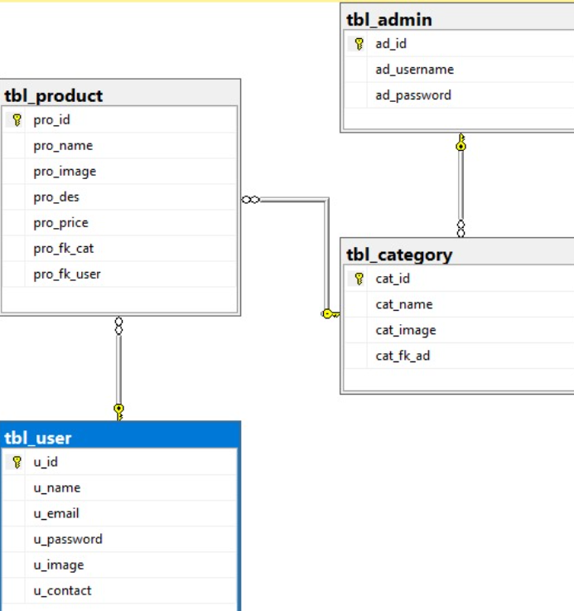

7.2 Class Diagram
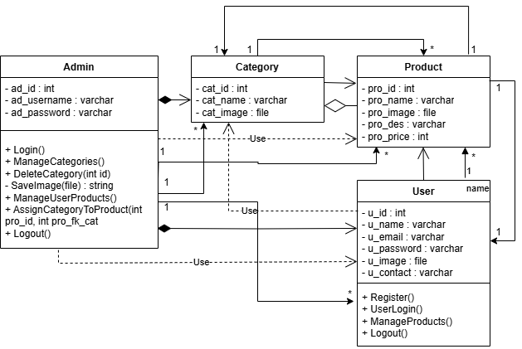
7.3 Use Case Diagram
%3CmxGraphModel%3E%3Croot%3E%3CmxCell%20id%3D%220%22%2F%3E%3CmxCell%20id%3D%221%22%20parent%3D%220%22%2F%3E%3CmxCell%20id%3D%222%22%20value%3D%22Manage%20Categories%22%20style%3D%22ellipse%3BwhiteSpace%3Dwrap%3Bhtml%3D1%3B%22%20vertex%3D%221%22%20parent%3D%221%22%3E%3CmxGeometry%20x%3D%22540%22%20y%3D%22320%22%20width%3D%22140%22%20height%3D%2270%22%20as%3D%22geometry%22%2F%3E%3C%2FmxCell%3E%3C%2Froot%3E%3C%2FmxGraphModel%3E
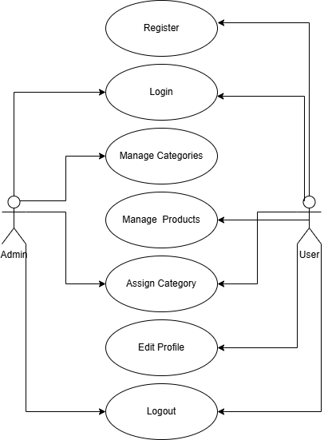

7.4 Project Design
